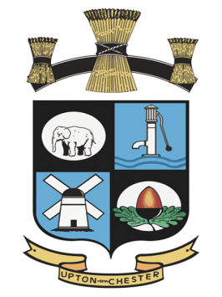
UPTON BY CHESTER AND DISTRICT
PARISH COUNCIL

18 Gladstone Road
Chester
CH1 4BY
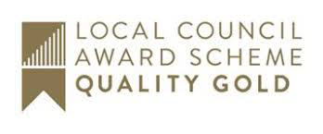
07584415343
Email: clerk@uptonbychester.org.uk

Minutes of the Meeting of Upton by Chester and District Parish Council Communications Committee held on 14 October 2019, 7.00pm, at Upton Pavilion, Upton, Chester.

Present: Cllr J Egerton-Parry, Cllr T Egerton-Parry, Cllr J Evans (Chairman) and
Cllr B Southward.
In attendance: Ms S Bull (Clerk and Proper Officer).

1. APOLOGIES FOR ABSENCE.
Resolved: that no apologies for absence were received; all present.

2. DECLARATIONS OF INTEREST.
No declarations of interest were made.

3. MINUTES.
Resolved: the Minutes of the meeting held on 9 September 2019 were approved as a correct record and signed by the Chairman.
Proposed by Cllr T Egerton-Parry, seconded by Cllr Southward.

4. DRAFT NEWSLETTER.
Resolved: that the draft newsletter will be amended as agreed. The Chairman will review the articles for grammar and typos and report back to the clerk.

5. PUBLIC SECTOR WEBSITE ACCESSIBILITY.
The clerk reported on recent legislation that requires public bodies’ websites to be accessible to all.
This may include partially sighted people or those with poor motor skills. The website should also be formatted for use on tablets and smart phones.
Resolved: that councillors will familiarise themselves with the requirements of the legislation. Amendments will be identified and included along with other work to update the website.

6. WEBSITE AND SOCIAL MEDIA.
Resolved: that a meeting to consider improvements to the website and social media platforms will take place on Thursday 24 October.

7. DATE AND TIME OF THE NEXT MEETING.
Resolved: the date and time of the next meeting will be on Monday 6 January 2020.

